There are a couple more things we need to look at to complete covering text objects in general to enable you to completely set up your own selection screens for your programs.

These are text symbols and messages.

Well, text symbols were used to replace literals in our program. For example, when we use the right statement, we can choose to use text symbols, which will enable us to reuse text we have already set up. And it gives us the added functionality of being able to use translated text within our program.

they are just place holders for text Instead of having a write statement

And we would do this by creating our right statement again, but instead of having a literal same surname, we would say use text dash and then a number. And this represents a text symbol that we can set up.

You must use text, which is this word here, followed by a three-digit number. You are allowed to use up to 1,000 text symbols in your program, of which each one can be translated into as many languages.

Now, there is a limitation to the length of a text symbol and that's 132 characters.

Now we have already seen how to get to text elements by using the menus when we had a look at selection text. But there is also another way we can get to it. And that's by using forward navigation. So, because I have just used this text double one, I can use forward navigation just like when we did with creating a database table.

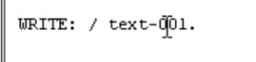

So, all I'll need to do is double-click this text-001.

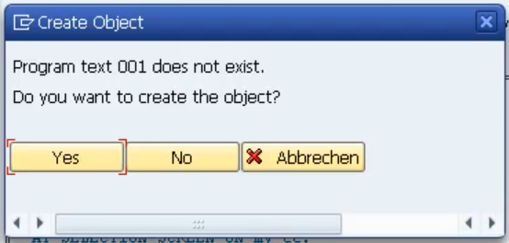

And now the system says do you want to create the object. And now it takes us straight into our text element screen.

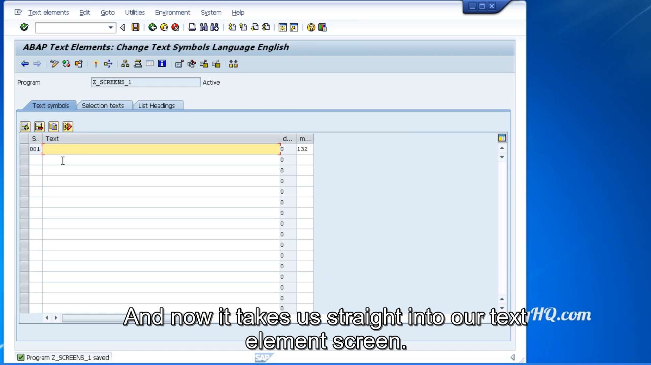

You can see it's using the code 001 that we defined in the program, and now all we need to do is enter some basic text into this field.

